## 

## 

horizontal line

POLARIS

AN HOSTEL KEEPING SYSTEM :

10.08.2022

**─**

SRIHAAS PIGILAM

2/4-ECE-20B91A04J1,

SRKR ENGINEERING COLLEGE,

BHIMAVARAM,ANDHRA PRADESH.

# INTRODUCTION

India is rapidly developing or growing in all sectors of vision and proving world dominance and yet it has its setbacks in every sector due to lack of proper utilization of automation or advanced technologies.

India is well known for its rich culture and heritage,it is expected that the contribution of this industry to the economy of India will grow 10.0 by 2023.This will place India as the third country globally in the tourism and hospitality industry.

In countries like Japan they have automation and use robots instead of workers from entry to exit of a restaurant or any hotels or any hostel .Even though India is one of the leading in those sectors we still have better ways to improve the cleanliness and hospitality.

In this Project we focus on an efficient system for maintaining the hostel rooms which the idea is taken from the hostel system from japan and various models of these similar projects into consideration.

# GOALS /SPECIFICATIONS

1. Effective way for cleansing of rooms.
2. Effective organization of workers
3. Reduces maintenance required for maintaining the workers
4. Easily understandable and multilingual option included for admin level
5. Fully virtual mode.

# EXISTING POINTS

1.Having one language to understand.

2.Seperate accessibility for Admins,Students.

## PROBLEMS IN EXISTING PROJECT

1.No multilingual option

2.No Proper Management System(Managing of work and the workers)

3.No Proper Allotment System(allotment of workers)

4.No Feedback system.

5.No complaint and suggestion system.

6.We have management systems for hotels and etc but there is no specific application for the school ,college ,university level.

# MISSING FEATURES:

1.Description about the food we order(ingredients and specialty)

2.Display time-requested,time-in ,time-out,

3.Disaply of picture and animations.(Just for appealing-#only for students)

4.Feedback and rating.

5.Notifying admin for assigning of workers (general notification and via email ).

6. Better student profile(Photo of student,Id no-#clz Specific).

7.Complaint raising and display that iin student profile and admin level.

8.Multilingual option.

## IMPLEMENTATION IN CURRENT PROJECT

1.Feedback and rating.

2.Admin level notification.

3.Proper Complaint system.

4.Displaying various time factors.

5.Multilingual option.

6.Proper allotment system.

7.Proper management system

8.Specifically designed for hostels of school to university level students.

# TECHNOLOGIES USED:

1. HTML5.
2. CCS3.
3. BOOTSTRAP(CSS FRAMEWORK).
4. FONT AWESOME ICONS(CSS FRAMEWORK).
5. JAVASCRIPT.
6. JAVASCRIPT LIBRARIES.
7. PHP.
8. MYSQL.

# TOOLS USED:

1. VISUAL STUDIO CODE(INTEGRATED DEVELOPMENT ENVIRONMENT).
2. XAMPP(SERVER ).
3. GOOGLE SHEETS.
4. GOOGLE DOCS.
5. GOOGLE DRIVE.
6. GITHUB.
7. WINRAR(TO EXTRACT ZIP FILES).
8. ONE NOTE(FOR NOTE MAKING).
9. CODEPEN.IO(TO TEST SOME PART).
10. COLOR PICKER.
11. OPERA GX BROWSER .

# REFERENCES:

1. <https://codepen.io/freeCodeCamp/full/qRZeGZ>
2. <https://codepen.io/krips_zala/pen/PjwLJe>
3. <https://www.simplilearn.com/tutorials/php-tutorial/php-login-form>
4. <https://www.w3schools.com/tags/default.asp>
5. <https://www.w3schools.com/css/default.asp>
6. <https://www.w3schools.com/sass/default.php>
7. <https://www.w3schools.com/cssref/default.asp>
8. <https://www.w3schools.com/js/default.asp>
9. <https://getbootstrap.com>
10. <https://www.raghwendra.com/blog/how-to-connect-html-to-database-with-mysql-using-php-example/>
11. <https://www.java.com/download/ie_manual.jsp>
12. <https://www.javascript.com>
13. <https://www.php.net/downloads.php>
14. <https://www.w3schools.com/sql/default.asp>
15. <https://www.w3schools.com/bootstrap/bootstrap_ver.asp>
16. <https://www.w3schools.com/howto/default.asp>
17. <https://www.w3schools.com/w3css/default.asp>
18. <https://www.w3schools.com/react/default.asp>
19. <https://www.mysql.com/downloads/>
20. <https://cssgradient.io>
21. <https://www.pexels.com>
22. <https://www.simplilearn.com/tutorials/php-tutorial/hello-world-in-php>
23. <https://code.visualstudio.com/download>
24. <https://www.freecodecamp.org/learn/responsive-web-design/>
25. <https://www.youtube.com/watch?v=mU6anWqZJcc&t=6012s>
26. <https://safetyculture.com/app/housekeeping/>
27. <https://fontawesome.com/kits>

# ABSTRACT:

An Analysis of POLARIS the web application for hostel management

Srihaas pigilam, SRKR ENGINEERING COLLEGE,

Project Title: An Hostel Keeping Website Portal

INTRODUCTION :

This project is about the hostel management system. There are different types of web applications or software circulating all around which gives us an idea about the new system of hostel management. Students now prefer the easy way that always makes their life easy.

In this project, we develop a web page for a hostel management site that includes the different types of login, and signup options for the new students,already registered students,different levels of admin access,and workers. Different types are categorized under one section of the web page.

And also it includes the address and contact number of the officials and members of the hostel if there is any issue there for any student they can easily contact and resolve their issue.

Nowadays we all know very well that students and educational institutions are shifted to the world of the internet. That is why the internet is the best thing around us. Our HTML, CSS, and JavaScript-based web application project is to develop a Hostel Management System.

It consists of student domain login and interface, Admin level login and interface and allotment of workers and workers level login for some purposes,feedback from students,complaint system for students. Students can contact the manager to solve the issue about the hostel rooms or can approach the manager of the hostel via email or whatsapp which are also linked to the homepage.

This website is developed using HTML5 & to add designs and make it more attractive we used CSS3, BOOTSTRAP, FONT AWESOME ICONS , COLOR GRADIENT TOOLS and JAVASCRIPT to make it as best as we can. Different photos are included to give students about the hotel and its management system.

This system is used to allot workers for hostel rooms for cleaning and other services Time-in and Time-out options and many other options, features are added for better satisfaction and proper application.

## **CONTENT OF THE APPLICATION:**

• LOGIN AND SIGN UP PAGE

• ABOUT

• NEWS

• CONTACT

• STUDENT LEVEL DASHBOARD(REQUEST OF WORKER)

• ADMIN LEVEL DASHBOARD(ALLOTMENT OF WORKER AND MANAGEMENT OF WORKERS,REGISTRATION OF NEW WORKERS AND ETC)

This web page is developed using HTML5, CSS3, BOOTSTRAP and javaScript. HTML5 is used to prepare all the web pages for the hostel management system. CSS3 is used to make it more attractive and elegant. Students are always attracted to the attraction we made for them. different types of loading are used for different font styling in it.

## **Modules:**

This project is divided into 4 parts:

The first part is named HTML Design, in this the programming it deals with the overall framework and rough design of web application for registration and login for various access-Student level access and Admin level access, student dashboard, admin level dashboard,worker level dashboard and each and every small design.

The second part is named CSS style. This file deals with the programming in CSS which gives the HTML the styling and helps it to look far more attractive in it. This module gives the looks and makes it attractive for students

The third part includes the different BOOTSTRAP AND FONT AWESOME ICONS codes for the elegant different font styles and design styles. There are different files present here for the styles and design in the project folder. Different images are included here and also a logo is there for the developer.

The fourth part includes the different PHP AND MYSQL codes for the storing of data and further backend processes.

# PROTOTYPE :

The upcoming slides give a detailed overview of the Project(Polaris-An Hostel keeping Online Website Portal).This project is used by using various front end and back end technologies.

Login and Sign up Page:

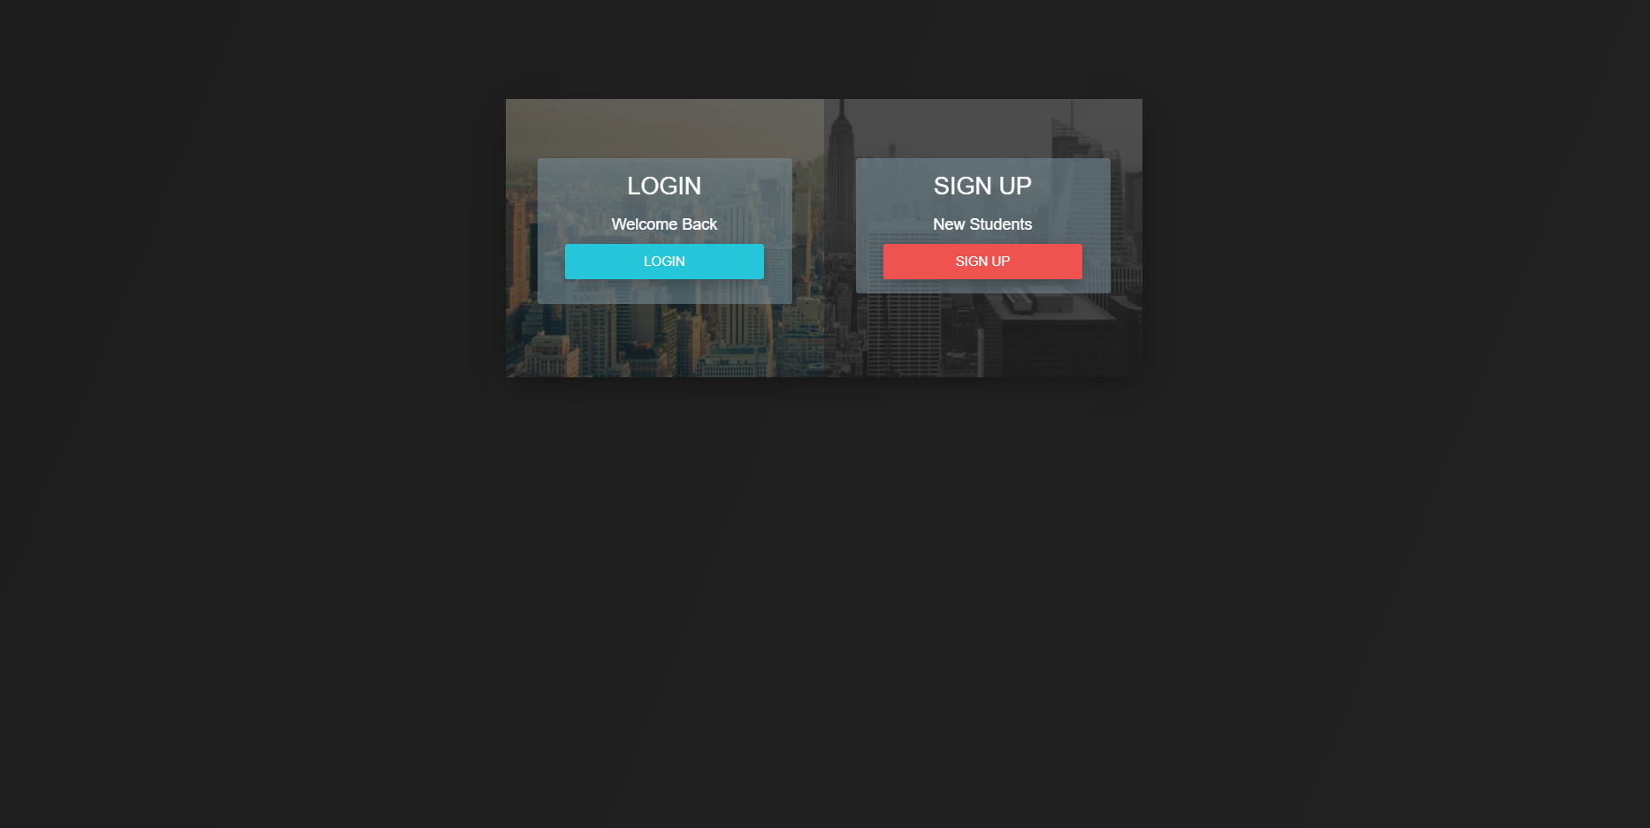

Student Level Login and Admin Level Login Page :

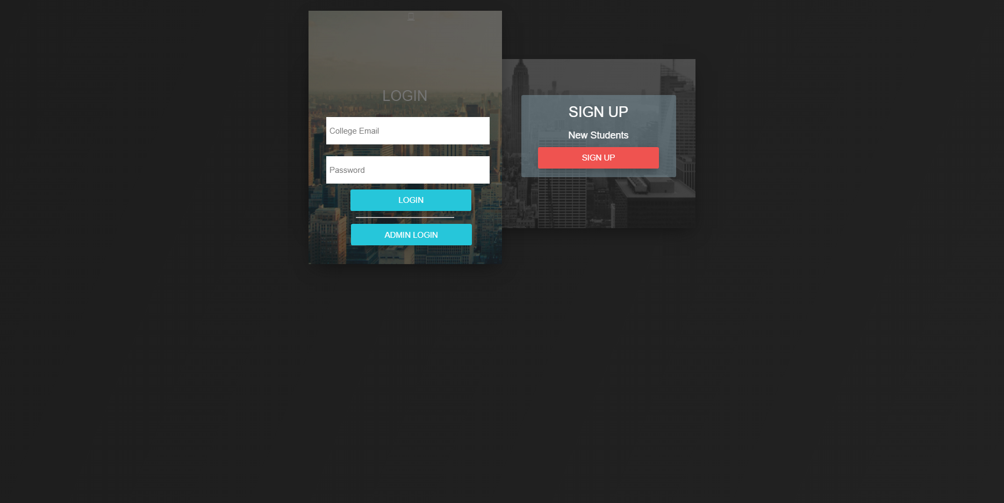

Admin Level Login Page :

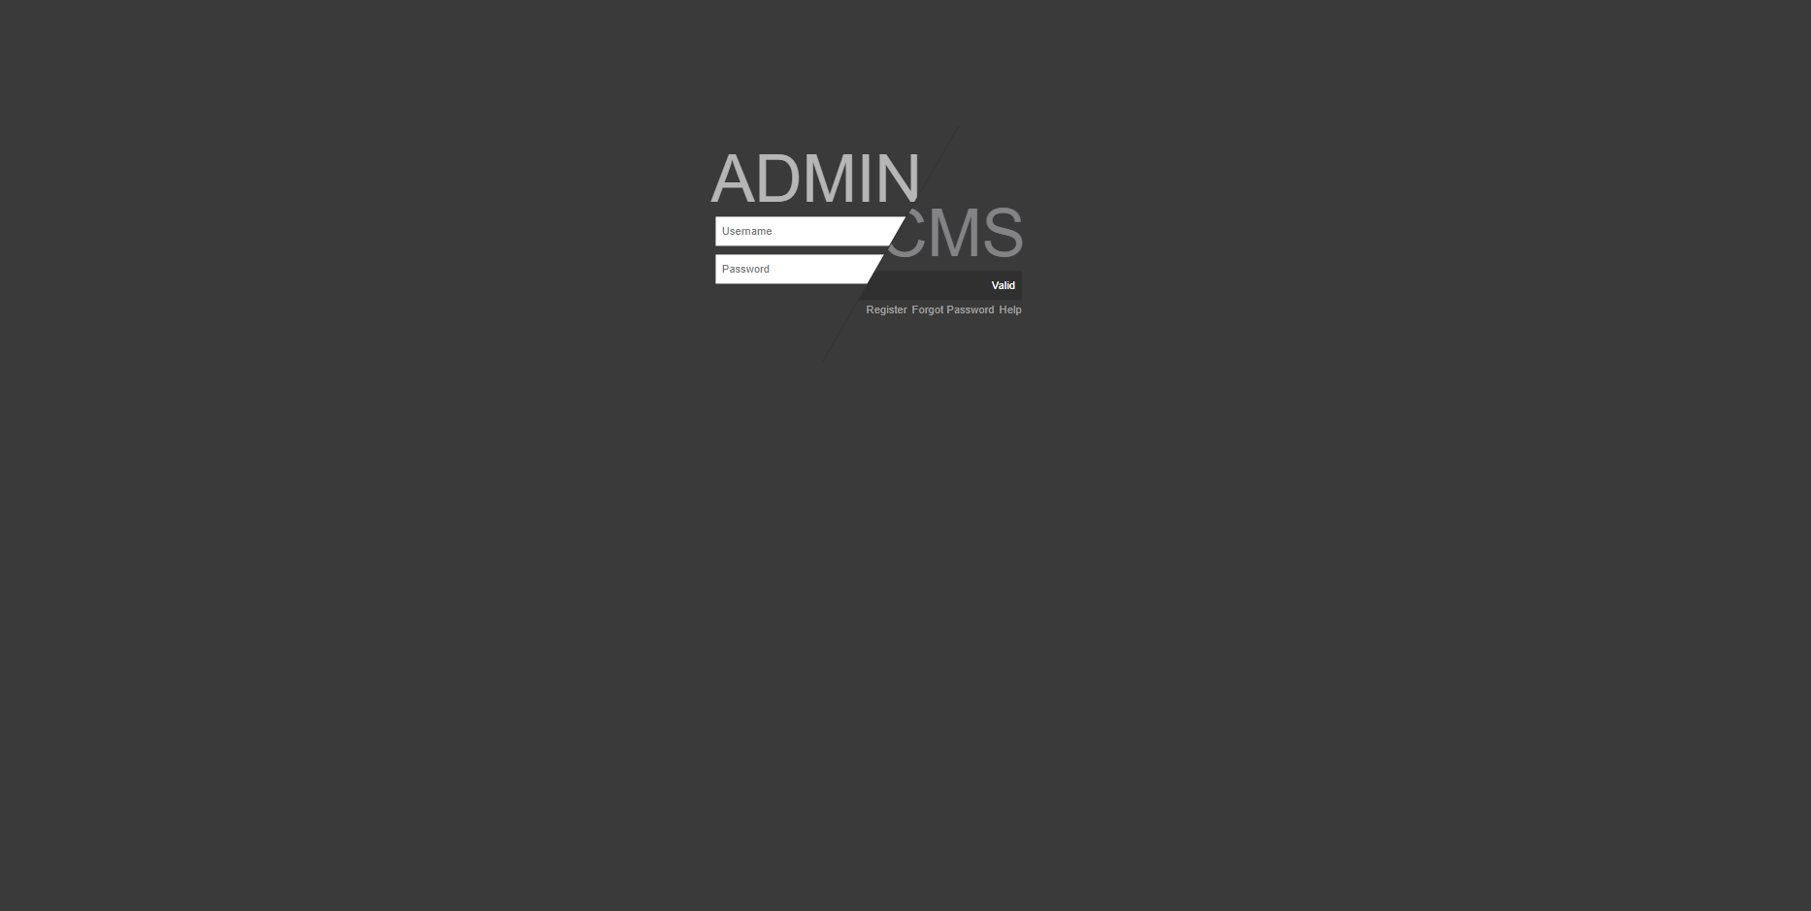

Sign up Page:

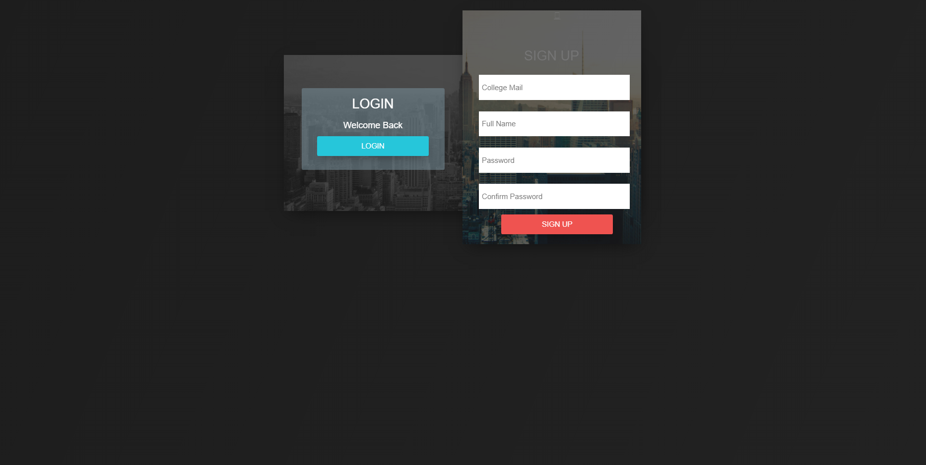

Student Dashboard After Login :

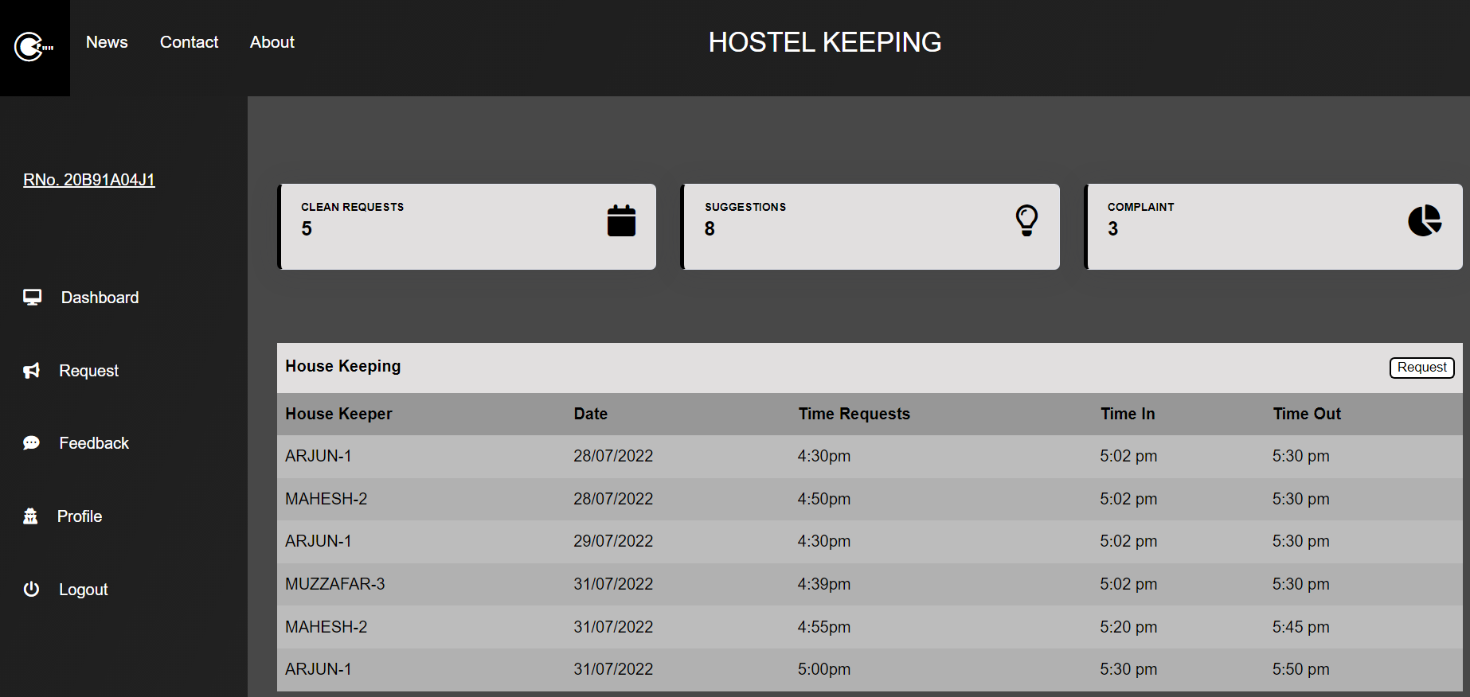

News Page :

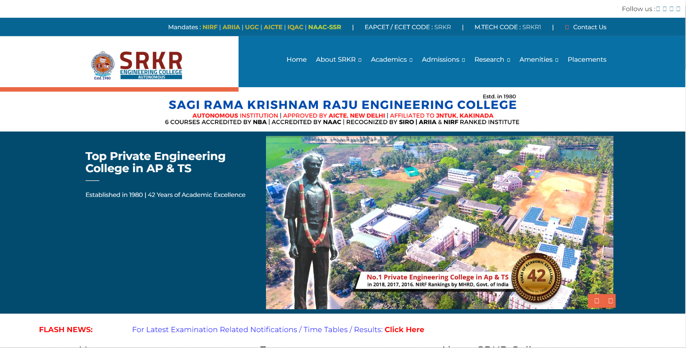

Contact Page:

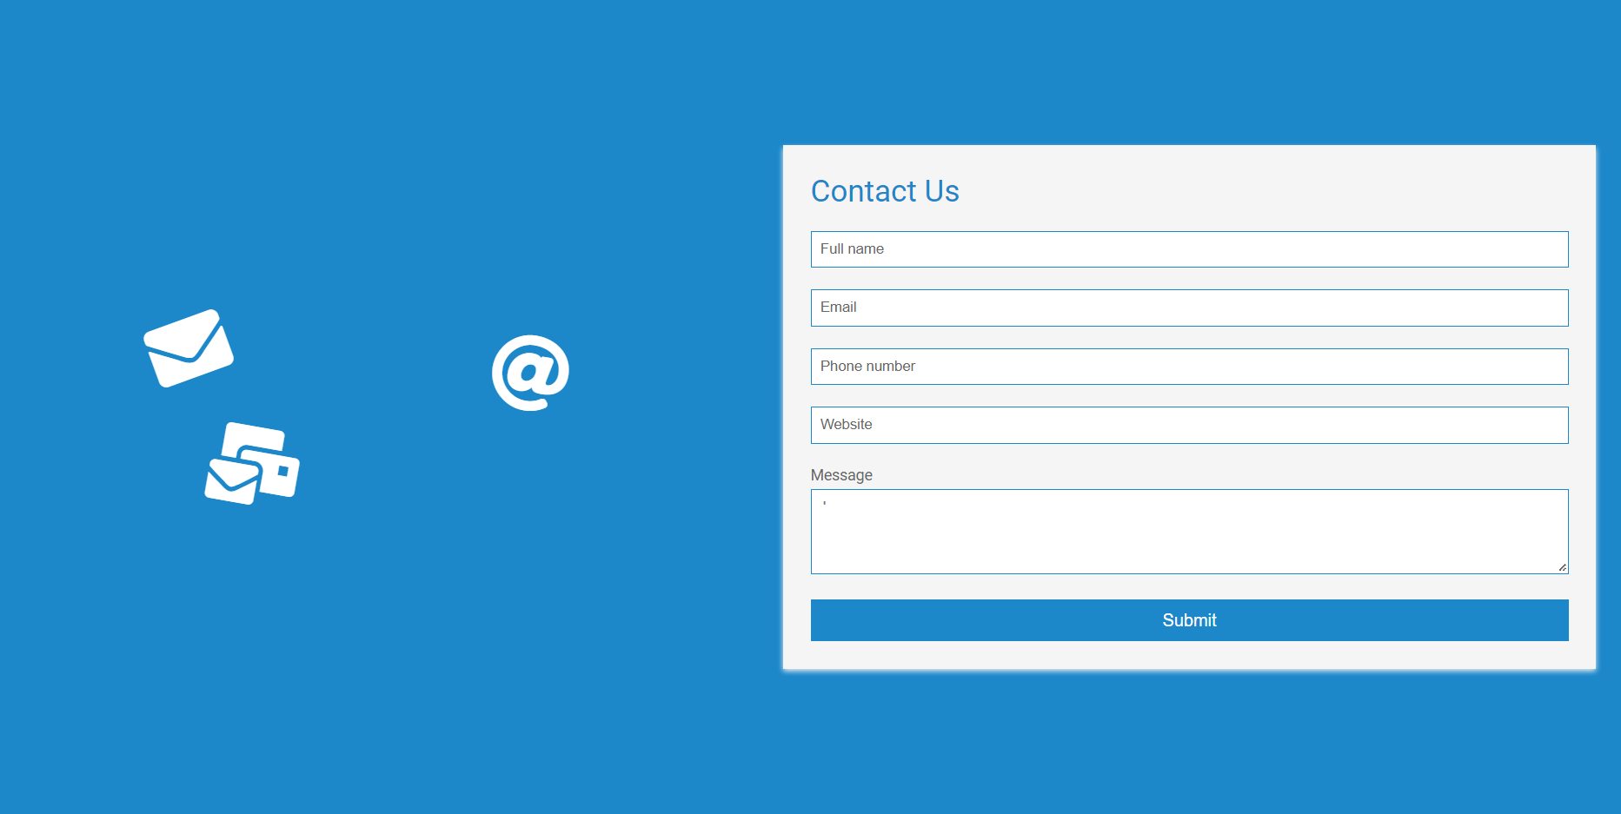

Feedback Page :

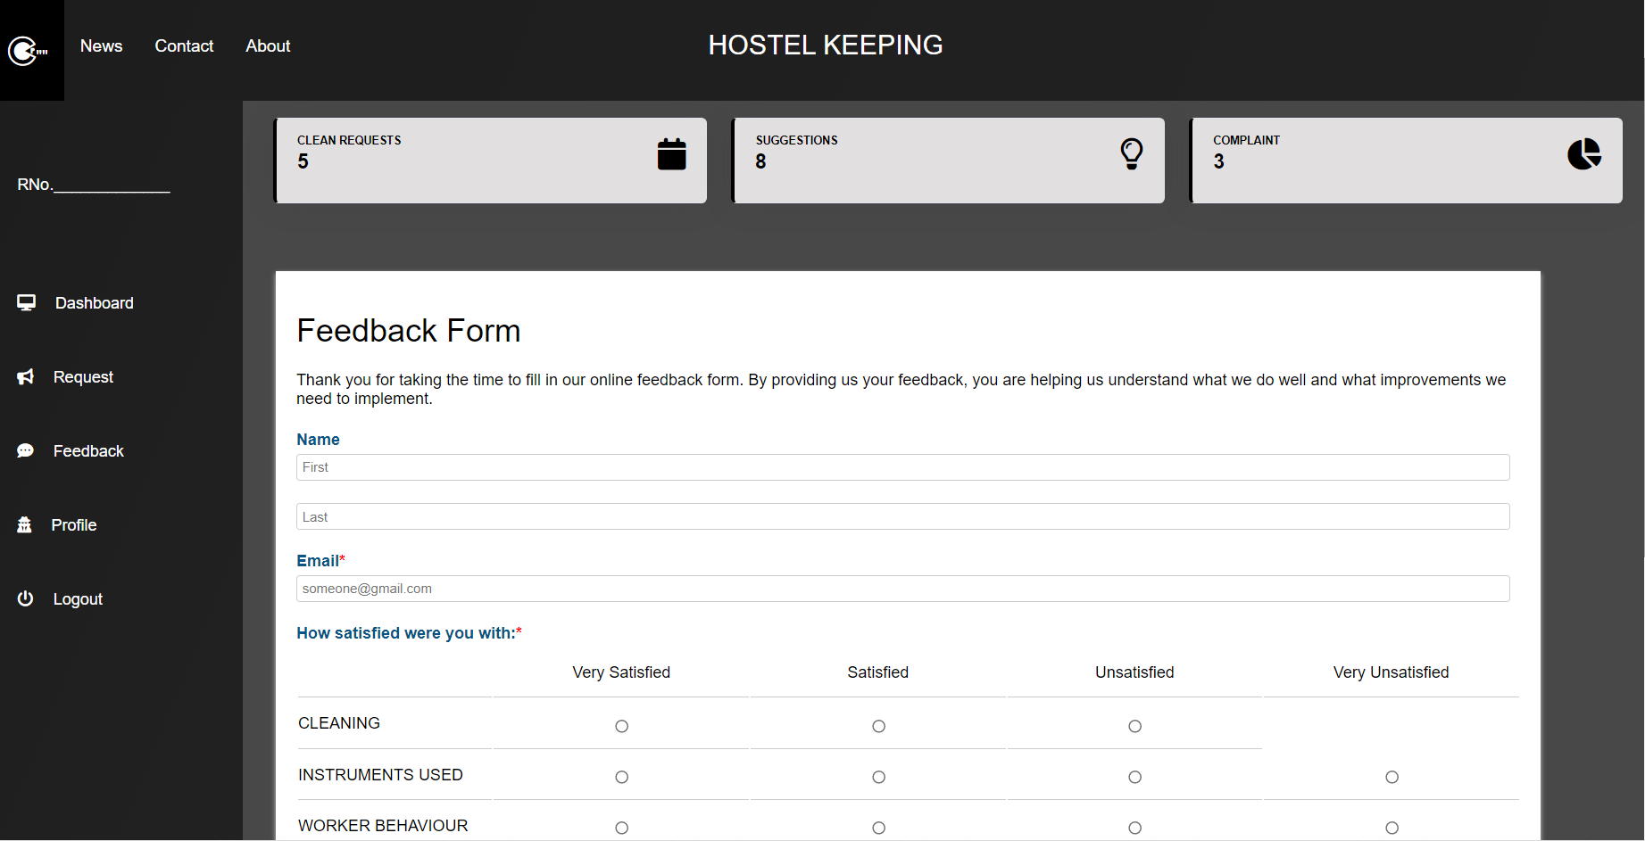

Profile Page :

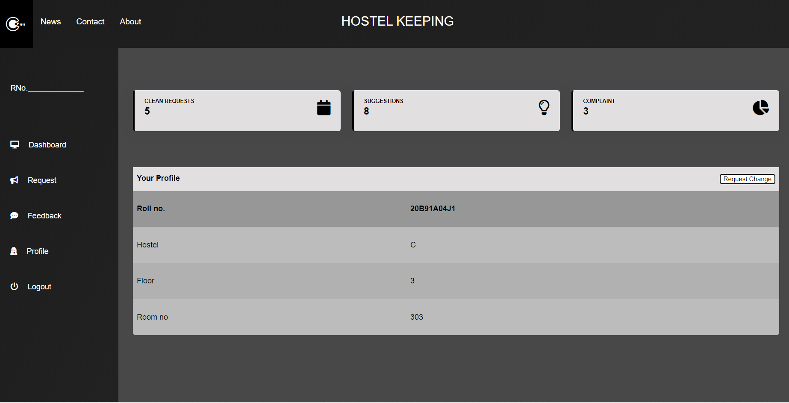

Admin Level Dashboard Page :

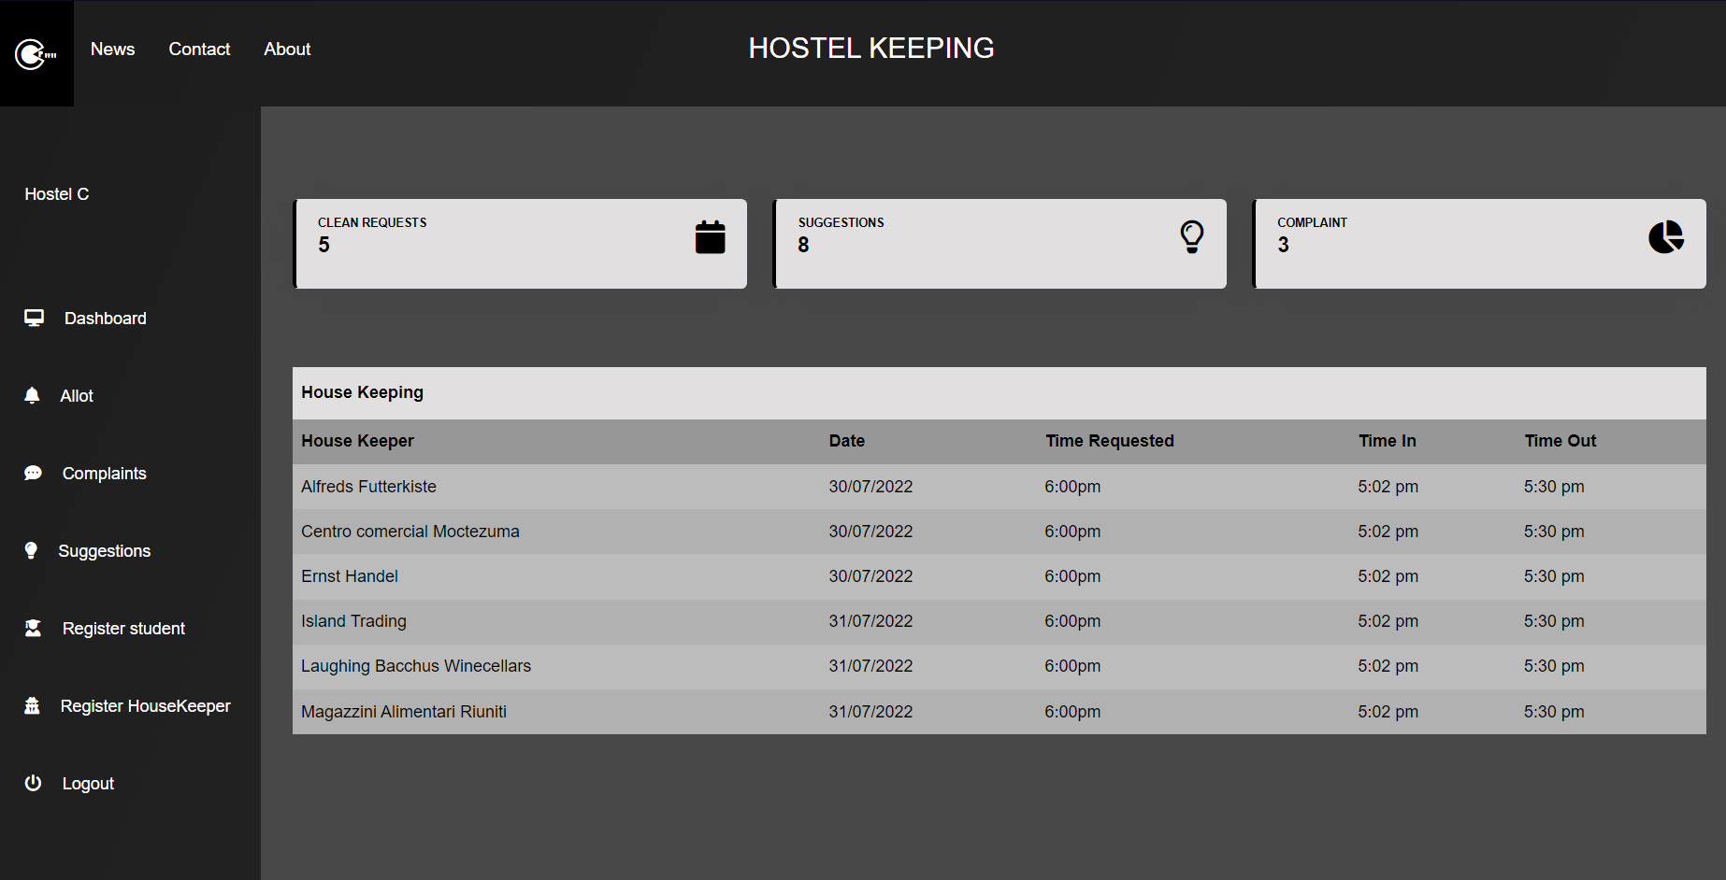

Total Logic Map Behind The Project :

